**Model Development Phase Template**

|  |  |
| --- | --- |
| Date | 09 JULY 2024 |
| Team ID | SWTID1720193784 |
| Project Title | Early Prediction Of Chronic Kidney Disease Using Machine Learning |
| Maximum Marks | 4 Marks |

**Initial Model Training Code, Model Validation and Evaluation Report**

The initial model training code will be showcased in the future through a screenshot. The model validation and evaluation report will include classification reports, accuracy, and confusion matrices for multiple models, presented through respective screenshots.

**Initial Model Training Code**

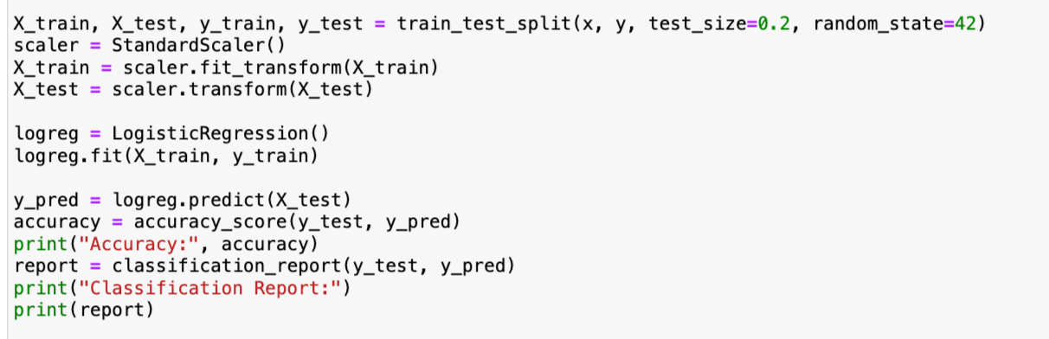

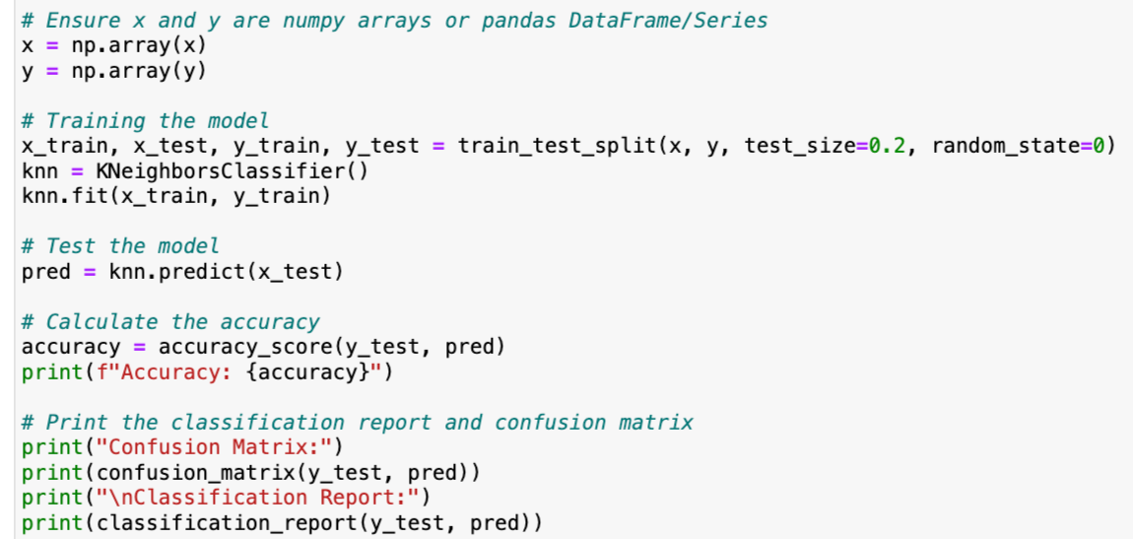

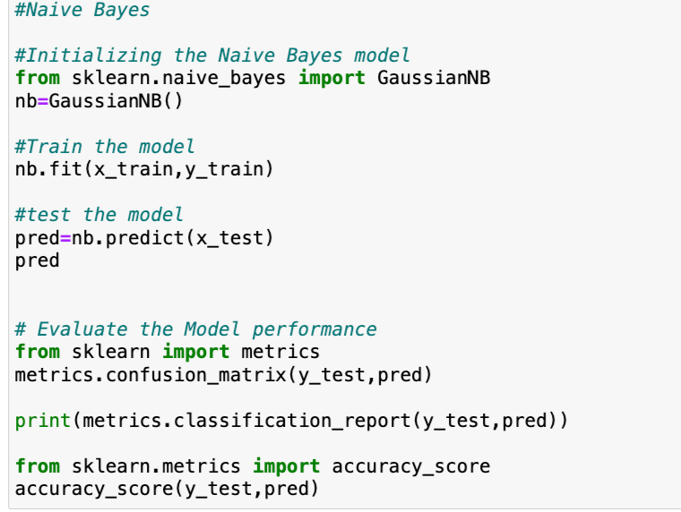

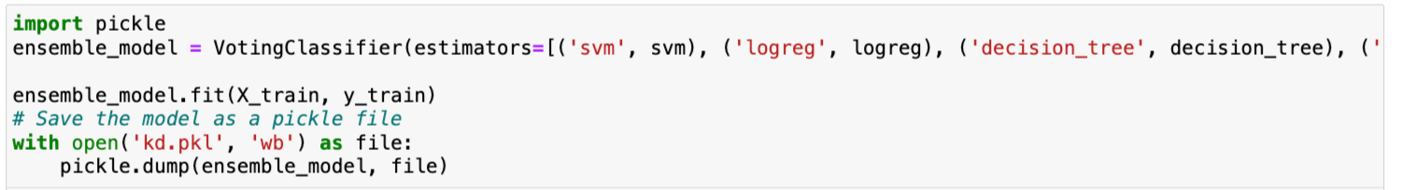

**Model Validation and Evaluation Report:**

|  |  |  |  |
| --- | --- | --- | --- |
| **Model** | **Classification Report** | **Accuracy** | **Confusion Matrix** |
| KNN | 1 | 97.5% | 2 |
| LOGISTIC REGRESSION | 1 | 98.75% | 2 |
| NAIVE BAYES | 3 | 57.5% | 1 |
| SVM | 1 | 97.5% | 2 |